KINGSTONE & THRUXTON GROUP PARISH COUNCIL
Minutes of an ordinary meeting of the parish council held on Wednesday 7th June 2023
At 19.00 in Kingstone Village Hall

Present:
Cllr Neil Howard, Cllr Denise Lloyd, Cllr Colin Pugh, Cllr Paula Rawbone, Cllr Colin Warrillow

In attendance:
Lisa Lewis (Parish Clerk), Steve Madison (Sports Association), PFO Paul Neate (Parish Footpath Officer) and six members of the public.

Agenda Ref | Minutes
1. | Co-option – no potential members present
2. | Apologies for absence – Were received and accepted from Cllr Lynne Thorne.
3. | To receive declarations of interest & written requests for dispensation none recorded.
4. | Approval of minutes and sign from parish council meeting held Wednesday 17th May 2023. It was RESOLVED to adopt the minutes as a true record, and they were signed by the chairman.
5.  5.1 | Members of the Public:-  Questions were raised by members of the public regarding:-  - Allotments – several queries and questions were discussed and addressed.  A councillor disagreed with the clerk and used inappropriate language. The chairman reminded them of adherence to the code of conduct. They took their papers, made a further comment to the clerk and left the meeting at 7:15PM.  Clerk’s Report and Correspondence Received:  Quotes and update received from the lengthsman:-  Traffic Management signs.  The signs left on the verge by the school were collected recently.  Village signs-Supply and fit. These are currently proposed as part of the 106 spend and the road traffic calming plans were discussed. It was noted that a further meeting will be held with the 106 team at Herefordshire Council.  £700 plus vat.  PROW-KS25 way marker posts.  £25 plus VAT materials only.  Footway/kerb line clearing on the B4349.  £650 plus VAT.  It was RESOLVED by a unanimous vote to proceed with the quotes for the replacement of the waymarkers at £25 plus VAT on the KS25 and Footway/ kerb line cleaning on the B4349 at £650 plus VAT. Clerk to action.  Updates  Parish Footpath Officer has been booked onto a brushcutter course. The clerk has ordered all required equipment from Ron Smith, this is to be collected on Thurs 8th June.  Equipment has been added to the Parish Council Insurance policy as a lumpsum for power tools at a replacement cost of £1400 on an All Risks basis. An excess of £100 applies. Cover is for anywhere in the UK. PPE insured on the same basis at £250 replacement. There is no additional charge and amended schedules will follow shortly.  Planning – FOR INFORMATION ONLY  None to note
6.  6.1  6.2  6.3  6.4  6.5  6.6  6.7 | Verbal Reports  Local Policing Team not present.  Ward Cllr not present.  Lengthsman not present but quotes received and noted under item 5.1  Village Hall Committee reported:  - New windows being installed on the 21st / 22nd  - A bingo had been held which raised £300 towards the refurbishment of the hall  - Doors will be replaced when enough money has been raised  - Bookings remain high  Sports Association Reported:  - No updates on the footpath.  - Security has been installed.  - Awaiting Drainage update.  Parish Footpath Office (PFO) Reported:  - KS2 – the walkway through the bog is to be extended.  - KS25 requires clearing – once training and risk assessments are in place it was RESOLVED to accept the PFO’s offer to clear the path.  Bike Track update:  - Basic pump track design drawn up.  - 2 quotes received so far to build the track. Estimated total costs approx. £4,000. It was noted that a £1000 grant had already been received from the Police Commissioner, therefore it was proposed that an additional amount of £3,000 be used from the general reserves. It was RESOLVED by a unanimous vote to amend the budget for the bike track to £4,000.  - It will be ready for the summer holidays.  - Signage being purchased. Design proof shown.
7.  7.1 | Appointment of Council Representatives to outside bodies:  John Smith Charity – it was RESOLVED to appoint Cllr Lloyd, Cllr Rawbone and Cllr Warrillow.
8.  8.1  8.2 | Financial Reports  The payments list for June, as shown in appendix 1 was APPROVED.  Banking - Bank balances and reconciliation for end of April 2023 were noted and statements signed by the chairman, see appendix 2. It was requested that a document showing the general and earmarked reserves is circulated for all future meetings. Clerk to put in place.
9. | Planning  231418 - 5 Tippetts Meadow, Kingstone, Herefordshire, HR2 9HW - Removal of rotting Silver Birch tree and replanting of suitable replacement Planning Search – Herefordshire Council.  It was RESOLVED to respond in support with no comments.
10. | Drainage No updates received.
11.  11.1  11.2 | Allotments  The land transfer document was received and noted, it was RESOLVED to approve the document and three councillors signed it, with the clerk as a witness. Clerk to return to the solicitor.  Cllrs Pugh, Rawbone and Warrillow were proposed as members and it was RESOLVED by a unanimous vote to appoint them as the Committee members.
12.  12.1  12.2  12.3 | Highways and Environmental Matters  Traffic Calming – already covered under item 5.1.  Dog waste emptying on the Sports Field, the costs were discussed and it was RESOLVED to defer the item to the next meeting for consideration of the costs.  Cottons Meadow Area – Cllr Pugh has taken photos and will progress this by completing a report for the clerk to forward to the Ward Councillor.
13.  13.1  13.2  13.3 | Village Planting  Potential costs were discussed and it was RESOLVED to defer until the next meeting when a clearer idea of costs will be available.  Potential planting locations were discussed and it was RESOLVED to defer until the next meeting.  An oak barrel has been kindly donated by the pub, it was RESOLVED to thank them for their kind donation and position the barrels at the Church Triangle.
14. | Thruxton Noticeboard – it was RESOLVED to defer the item until the next meeting.
15. | Items for next agenda - None
16. | Date of next parish council meeting is Wednesday 5th July 2023.
 | Meeting closed to the public at 8.11pm
17. | Closed Session  The terms of the clerk’s contract were discussed and it was RESOLVED to offer the clerk additional hours.

SIGNED………………………………………………………… DATED…………………………….

Appendix 1
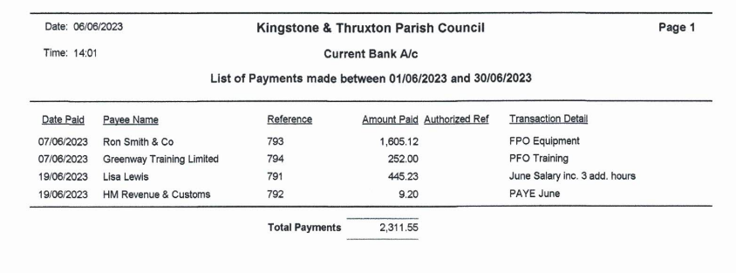
Appendix 2
